**AI Powered Automated Traffic Management System**

**REPORT**

***Submitted by***

**SHANMUGA PRIYA RAANJANI SH (2116220701262)**

**SHANMUGA DIVYA K (2116220701261)**

**GURUBARAN T (2116220701522)**

***in partial fulfillment for the award of the degree of***

**BACHELOR OF ENGINEERING**

***in***

# COMPUTER SCIENCE AND ENGINEERING



**RAJALAKSHMI ENGINEERING COLLEGE ANNA UNIVERSITY, CHENNAI**

# MAY 2025

RAJALAKSHMI ENGINEERING COLLEGE, CHENNAI

**BONAFIDE CERTIFICATE**

Certified that this Project titled **“AI Powered Automated Traffic Management System”**

is the Bonafide work of **“SHANMUGA PRIYA RAANJANI SH (2116220701262), SHANMUGA DIVYA K (2116220701261), GURUBARAN T (2116220701522)”** who carried out the work under my supervision. Certified further that to the best of my knowledge the work reported herein does not form part of any other thesis or dissertation on the basis of which a degree or award was conferred on an earlier occasion on this or any other candidate.

# SIGNATURE

## Dr. P. Kumar., M.E., Ph.D.,

Professor and Head of the department

Department of Computer Science and Engineering,

Rajalakshmi Engineering College, Chennai - 602 105.

# SIGNATURE

Dr. S. Senthil Pandi., M.E., Ph.D.,

Associate Professor

Department of Computer Science and Engineering,

Rajalakshmi Engineering College, Chennai-602 105.

Submitted to Project Viva-Voce Examination held on

**Internal Examiner External Examiner**

# ABSTRACT

Urban mobility is nevertheless significantly hampered by traffic infractions, which lead to traffic bottlenecks, crashes, and a decline in road safety. This article presents an AI-powered Traffic Management System (ATMS) that employs cloud computing, machine learning, and potent computer vision to detect and penalize traffic violations in real time, thereby achieving a Zero Violation Point.The proposed system integrates with the existing CCTV infrastructure to monitor urban traffic flow without requiring the deployment of additional hardware.Using deep learning models like YOLOv8 and OpenCV, the system can accurately detect violations such as drivers without wearing seatbelts, riders without helmets, red light jumping, lane indiscipline, and wrong-way driving.The core of the system is an AI-powered video processing module that continuously analyzes live camera feeds to identify violations and obtain vehicle registration numbers using optical character recognition (OCR). The collected license plate numbers are compared to government databases (RTO APIs) to retrieve owner information. After successful identification, an automatic e-challan is created and sent to the offender via SMS or WhatsApp notifications to guarantee a seamless fine issuance procedure. While the backend is built using FastAPI/Django to manage violation records, PostgreSQL/MongoDB serves as the primary database for recording traffic violations and payment statuses.The technology combines violation detection with AI-driven traffic planning and predictive analytics to increase road efficiency. By analyzing historical traffic data and present congestion levels, the technology makes dynamic recommendations for the optimal traffic signal lengths to minimize delays and improve flow.A specialized officer dashboard (made with React.js/Angular) that provides real-time violation monitoring, statistical insights, and data-driven decision-making tools can be used by traffic authorities to enforce stricter traffic laws. The software also integrates payment mechanisms (PayTM, Razorpay, and UPI) to reduce administrative burden and speed up fine settlements.In contrast to traditional traffic monitoring solutions that rely on expensive hardware setups or manual involvement, this approach stresses a scalable and affordable software-based solution. By utilizing cloud-based processing (AWS Lambda, Google Cloud Functions) and asynchronous task queues (Kafka, Celery), the system ensures exceptional efficiency in managing several live video feeds while maintaining real-time responsiveness.

# ACKNOWLEDGMENT

Initially we thank the Almighty for being with us through every walk of our life and showering his blessings through the endeavor to put forth this report. Our sincere thanks to our Chairman **Mr. S. MEGANATHAN, B.E, F.I.E.**, our Vice Chairman **Mr. ABHAY SHANKAR MEGANATHAN, B.E., M.S.,** and our respected Chairperson **Dr. (Mrs.) THANGAM MEGANATHAN**, **Ph.D.,** for providing us with the requisite infrastructure and sincere endeavoring in educating us in their premier institution.

Our sincere thanks to **Dr. S.N. MURUGESAN, M.E., Ph.D.,** our beloved Principal for his kind support and facilities provided to complete our work in time. We express our sincere thanks to **Dr. P. KUMAR, M.E., Ph.D.**, Professor and Head of the Department of Computer Science and Engineering for his guidance and encouragement throughout the project work. We convey our sincere and deepest gratitude to our internal guide, we are very glad to thank our Project Coordinator**, DR. S. SENTHIL PANDI., M.E., Ph.D.,** Associate Professor Department of Computer Science and Engineering and **MS.** **U. FARJANA** **M.Tech.,** Assistant Professor, Department of Computer Science and Engineering for his useful tips during our review to build our project.

**SHANMUGA PRIYA RAANJANI SH 220701261**

**SHANMUGA DIVYA K 220701262**

**GURUBARAN T 220701522**

**TABLE OF CONTENTS**

**CHAPTER NO. TITLE PAGE NO.**

|  |  |  |
| --- | --- | --- |
| **ABSTRACT i**  **ACKNOWLEDGMENT ii** | | |
| **LIST OF TABLES iii** | | |
| **LIST OF FIGURES iv** | | |
| **LIST OF ABBREVIATIONS v** | | |
| **1. INTRODUCTION** | **1** |
| 1.1 GENERAL | 1 |
| 1.2 OBJECTIVES | 1 |
| 1.3 EXISTING SYSTEM | 2 |
| **2. LITERATURE SURVEY** | **2** |
| **3. PROPOSED SYSTEM** | **9** |
| 3.1 GENERAL | 9 |
| 3.2 SYSTEM ARCHITECTURE DIAGRAM | 9 |
| 3.3 DEVELOPMENT ENVIRONMENT | 10 |
| 3.3.1 HARDWARE REQUIREMENTS | 10 |
| 3.3.2 SOFTWARE REQUIREMENTS | 10 |
| 3.4 DESIGN THE ENTIRE SYSTEM | 10 |
| 3.4.1 ACTIVITYY DIAGRAM | 10 |
| 3.4.2 DATA FLOW DIAGRAM | 11 |
| 3.5 STATISTICAL ANALYSIS | 12 |
|  |  |
|  |  |
| **4. SYSTEM ARCHITECTURE** **14**  4.1 ACTIVITY DIAGRAM 15  4.2 DFD DIAGRAM 15  4.3 COMPARISON GRAPH 16  4.4 SEQUENCE DIAGRAM 26  **5. DATASET FOR TRAINING 17**  5.1 PERFORMANCE EVALUATION  AND OPTIMIZATION 17  5.2 CONFUSION MATRIX 17  5.3 WEB PAGE FOR TRAFFIC PREDICTION 18  5.4 PREDICTION RESULT 18 | | | |  |
| **6. MODULE DESCRIPTION 19** |  |

6.1 SYSTEM ARCHITECTURE 19

* 1. USER INTERFACE DESIGN 20
  2. BACK-END INFRASTRUCTURE 20

**7. DATA COLLECTION & PREPROCESSING 21**

* 1. DATASET & DATA LABELLING 21

7.2 DATA PREPROCESSING 22

7.3 FEATURE SELECTION 22

* 1. CLASSIFICATION & MODEL SELECTION 23
  2. PERFORMANCE EVALUATION 24

7.6 MODEL DEPLOYMENT 24

7.7 CENTRALIZED SERVER & DATABASE 25

**8. SYSTEM WORKFLOW 26**

8.1. USER INTERACTION 26

8.2. VEHICLE DETECTION & TRAFFIC STATE MONITORING 27

8.3 CLOUD INTEGRATION & COORDINATION 27

* 1. TRAFFIC VIOLATION DETECTION & REPORTING 28

**9. IMPLEMENTATIONS AND RESULTS**  **28**

9.1. IMPLEMENTATION 28

* 1. OUTPUT SCREENSHOTS 29

1. **CONCLUSION AND FUTURE ENHANCEMENT** **32**
   1. CONCLUSION 32
   2. FUTURE ENHANCEMENT 33

**REFERENCES** **33**

## LIST OF ABBREVIATIONS

**S. No ABBR Expansion**

1 AI Artificial Intelligence

2` API Application Programming Interface

1. AJAX Asynchronous JavaScript and XML
2. ASGI Asynchronous Server Gateway Interface
3. AWT Abstract Window Toolkit
4. BC Block Chain
5. CSS Cascading Style Sheet
6. DFD Data Flow Diagram
7. DSS Digital Signature Scheme
8. GB Gradient Boosting
9. JSON JavaScript Object Notation
10. ML Machine Learning
11. RF Random Forest
12. SQL Structure Query Language
13. SVM Support Vector Machine



1. **INTRODUCTION**
   1. **General**

An AI-driven automated traffic violation recognition system is a modern solution designed to enhance traffic management and road safety. Traditional traffic enforcement relies heavily on human monitoring, which can be inconsistent and resource-intensive. With the rapid advancement of artificial intelligence (AI), machine learning (ML), and computer vision, it has become possible to automate the detection and reporting of traffic violations such as speeding, red-light jumping, illegal parking, and lane violations.The system typically integrates video surveillance cameras, real-time image processing, and AI models to detect violations accurately and efficiently. Advanced algorithms analyze video feeds or still images to identify vehicles and their actions, automatically flagging any rule-breaking behavior. Additionally, license plate recognition (ANPR Automatic Number Plate Recognition) technology is used to identify offending vehicles and issue penalties.This AI-based approach reduces the need for manual enforcement, ensures continuous monitoring, and minimizes human error and bias. It also encourages safer driving habits among motorists due to the higher likelihood of detection and punishment for violations. Overall, AI-driven traffic violation recognition is emerging as a crucial component of smart city infrastructure, improving traffic flow, enhancing safety, and ensuring that traffic laws are enforced fairly and consistently across diverse urban environments.

* 1. **Objective**

The primary objective of an AI-driven automated traffic violation recognition system is to improve traffic law enforcement while enhancing public safety and efficiency. It aims to minimize the reliance on human personnel for traffic monitoring and reduce human error and bias in violation detection. By leveraging AI technologies like computer vision and deep learning, the system seeks to automatically detect and record traffic violations in real-time without the need for manual intervention.Key goals include enhancing the accuracy and speed of violation detection, reducing road accidents caused by reckless driving, and promoting adherence to traffic rules among drivers. The system is designed to collect solid, legally admissible evidence — including photographs and video clips — to support the enforcement of penalties. Additionally, it supports traffic authorities by generating real-time alerts and detailed violation reports, thereby streamlining administrative processes.Another important objective is to integrate the system into broader smart city initiatives, facilitating better traffic flow management and data-driven urban planning.

* 1. **Existing System**

Currently, traffic law enforcement in many regions primarily depends on manual observation by traffic police or basic sensor-based systems like speed cameras and red-light cameras. Traditional systems often involve fixed cameras installed at key junctions, capable of capturing images or videos when specific events, such as running a red light, occur. These systems usually rely on simple motion detection or pre-defined sensor triggers, and while they help in basic violation recording, they are limited in scope, accuracy, and adaptability. Existing setups often struggle with issues like false detections, inability to recognize complex violations (such as illegal U-turns or lane changes), and poor performance under challenging weather or lighting conditions. Moreover, manual ticketing by traffic personnel remains a major method of enforcement, which can lead to inconsistencies, biases, and increased operational costs.In more advanced regions, systems like ANPR are used for detecting speeding or stolen vehicles, but even these often lack AI-driven behavior analysis. Emerging smart city projects are beginning to deploy more intelligent, AI-based solutions, but large-scale, fully autonomous traffic violation systems are still limited to pilot projects or select cities. Thus, there is a strong need to move toward more comprehensive, AI-driven approaches to enhance detection efficiency, coverage, and fairness in traffic law enforcement.

1. **LITERATURE SURVEY**

**[1**] This article suggests an AI-powered traffic management system that integrates cloud computing, optical character recognition, and computer vision for real-time traffic violation detection and penalty issuance in order to reach Zero Violation Point. The system employs deep learning models (YOLOv8, OpenCV, and EasyOCR) to monitor lane indiscipline, red light jumping, helmetless riders, and seatbelt breaches using the existing CCTV infrastructure. An OCR-based license plate recognition system detects violations and automatically generates e-challans via SMS and WhatsApp using the RTO database. The system's predictive analytics and AI-driven signal optimization ensure efficient traffic flow. This approach increases the precision of infraction detection and aligns with Super-Resolution GAN-based techniques for better vehicle identification in challenging circumstances. By eliminating manual policing, reducing corruption, and enhancing traffic law enforcement, the technology contributes to safer roads and smarter cities. Given its scalability, affordability, and ease of implementation, the proposed method is an excellent choice for updating urban traffic management.

**[2]** In order to ensure zero violation points, this study presents an AI-powered traffic control system that employs computer vision and deep learning to identify infractions in real time and assess fines. The system uses YOLOv8, OpenCV, and OCR to scan CCTV footage and identify traffic violations such as helmet-less riding, seatbelt violations, and red light jumping. Following the retrieval of car license plates using deep learning-based OCR models and cross-referencing with RTO databases, violators are automatically sent e-challans by WhatsApp or SMS. The technique, which is consistent with advanced license plate recognition (LPR) research, employs deep learning techniques to improve identification in complex situations with low-light, skewed, or fuzzy pictures. The software-driven approach eliminates manual enforcement, reduces corruption, and maximizes traffic flow through AI-based predictive analytics, making it scalable, cost-effective, and ideal for integration into smart cities. The system significantly increases road safety and compliance while ensuring seamless digital enforcement of traffic laws.

**[3]**This article presents an ai-powered traffic control system that employs computer vision and deep learning to detect and penalize violations in real time enabling the achievement of zero violation point through the integration of yolov8 OpenCV and ocr the system analyzes cctv feeds to identify helmet-less cyclists seatbelt violations and red light jumping violations are detected using deep learning-based license plate recognition lord and e-challans are immediately distributed by SMS or WhatsApp the approach is consistent with optimal yolov4-based vehicle detection research which uses attention processes and enhanced feature extraction to improve detection accuracy in complex scenarios because it reduces manual enforcement enhances traffic flow using ai-driven predictive analytics and ensures automatic violation tracking the system is scalable cost-effective and ideal for smart city integration this study bridges the gap between deep learning advancements in vehicle detection and automated traffic law enforcement resulting in safer roads and better adherence to traffic laws

**[4]** This article proposes an AI-powered traffic management system that combines computer vision, deep learning, and OCR-based vehicle identification to ensure Zero Violation Point in order to identify and penalize traffic offenses in real-time. Using YOLOv8, OpenCV, and neural network-based OCR, the system analyzes CCTV footage to identify seatbelt violations, lane indiscipline, and motorcycle riders without helmets. After the obtained license plate numbers are matched with RTO databases, violators are automatically sent e-challans through SMS or WhatsApp. In line with neural network-based number plate recognition research, this technique improves plate detection in challenging motion, lighting, and weather conditions. The technique uses deep learning algorithms to improve plate recognition, ensuring accurate identification of criminals. The automated enforcement system increases road safety and compliance by decreasing manual policing. Because of its scalable and reasonably priced architecture, this AI-driven system is ideal for modern urban traffic management. It ensures efficient monitoring, fewer violations, and optimized traffic flow in smart cities.

**[5]** This study presents an AI-powered traffic management system that strives for Zero Violation Point by integrating computer vision, deep learning, and OCR-based vehicle identification for real-time traffic violation detection and penalty issues. The system uses neural network-based OCR, OpenCV, and YOLOv8 to scan CCTV footage and identify violations like helmet-less riding, red-light jumping, and seatbelt violations.To increase detection accuracy, vehicle license plates are re-identified across many surveillance zones using CNN-based re-ranking algorithms. This approach is in line with zone-specific vehicle re-identification research and enhances traffic rule enforcement and violation tracking across many sites. By automating fine issuing through connection with RTO databases and digital notifications, the solution eliminates manual policing, increases compliance, and reduces corruption. Through intelligent automation, the system ensures safer roads and improved traffic management, making it scalable, cost-effective, and ideal for smart city applications. It consists of strategic zone surveillance and AI-powered traffic analytics.

**[6]** In order to achieve zero violation points, this study presents an AI-powered traffic control system that employs real-time infringement recognition and automatic penalty issuance. Using refined YOLOv4, OpenCV, and OCR, the system examines CCTV footage to find violations like helmet-less riding, red-light jumping, and seatbelt non-compliance. Following the retrieval of license plates using deep learning-based OCR models and cross-referencing with RTO databases, violators are automatically sent e-challans via WhatsApp or SMS. This approach is consistent with state-of-the-art research on vehicle detection using optimized YOLOv4, which incorporates attention mechanisms and enhanced feature extraction to increase accuracy in challenging environmental conditions. Using zone-based tracking, AI-driven predictive analytics, and automated enforcement, the system ensures efficient violation detection, less manual intervention, and enhanced traffic flow. The scalable and cost-effective architecture of this AI-driven solution, which employs intelligent automation to enhance road safety, law enforcement, and urban mobility, makes it ideal for smart city traffic management.

**[7]**This article presents an ai-powered traffic management system that use real-time traffic infraction detection and automatic fee issuance in order to reach zero inflection point using yolov8 opencv and ocr-based number plate identification the system uses cctv surveillance to monitor violations like riding without a helmet failing to wear a seatbelt and running red lights when detected vehicles are matched to rto databases e-challans are provided via sms or whatsapp our research combines ai-based countermeasures and automated enforcement technologies with red-light running behavior prediction models to improve accuracy in complex traffic scenarios machine learning-powered predictive analytics enhanced traffic monitoring driving behavior analysis and rule enforcement by eliminating manual policing reducing corruption and optimizing urban mobility this scalable ai-driven system ensures efficient traffic management safer roads and better adherence to traffic laws the proposed approach promotes smart city initiatives and paves the way for data-driven cutting-edge traffic regulating technologies

**[8]**This article presents an ai-powered traffic management system that integrates computer vision deep learning and ocr-based vehicle identification to detect traffic violations in real time and enforce penalties in order to achieve zero violation point the technology uses yolov8 opencv and paddle ocr to analyze cctv footage in order to identify red-light runners helmet-less bikers and seatbelt violations following the retrieval of license plates using deep learning-based ocr techniques and cross-referencing with rto databases violators receive e-challans via whatsapp or sms this work supports advanced anpr and vehicle recognition models by utilizing yolox mobilenet-v2 and gradcam to enhance real-time accuracy in challenging weather conditions the system combines deep learning for automated law enforcement and vehicle tracking ensuring efficient traffic monitoring reduced manual intervention and enhanced road safety because of its scalable design and ai-driven analytics this system is inexpensive ideal for smart cities and a significant step toward automated traffic law enforcement and better urban mobility

**[9]** In order to achieve zero violation points, this study presents an AI-powered traffic control system that employs real-time infraction detection and automatic fine issuance. The system processes CCTV footage using YOLOv8, OpenCV, and OCR to detect helmetless cyclists, seatbelt violations, and red-light running. Following the retrieval of license plates and their comparison with RTO databases, violators are automatically sent e-challans via SMS or WhatsApp.This approach enhances real-time violation monitoring and aligns with low-light anomaly detection research by utilizing deep learning-based vehicle recognition and image enhancement techniques. By using YOLOv8 for object detection in complex scenarios, the technique ensures improved rule enforcement, reduced false positives, and higher accuracy. With AI-driven predictive analytics and scalable cloud-based deployment, this system eliminates human policing, enhances compliance, and optimizes urban traffic management. The technology's low cost and advanced automation architecture make it ideal for smart city applications, which significantly improve road safety and traffic discipline.

**[10]** In order to attain Zero Violation Point, this article introduces an AI-powered traffic management system that uses automated fine issuing and real-time traffic violation detection. The system uses CCTV surveillance to identify helmet-less motorcyclists, seatbelt infractions, and lane discipline violations using computer vision and deep learning. Violators receive automated e-challans via SMS or WhatsApp once identified vehicles are subjected to OCR-based number plate recognition and cross-referenced with RTO databases.In line with studies on lane-keeping assistance based on Model Predictive Control (MPC), the system improves intelligent traffic optimization, lane adherence enforcement, and real-time vehicle tracking. The method lowers traffic and increases adherence to traffic laws by using MPC for predictive decision-making. Minimal human interaction and effective urban mobility management are guaranteed by the scalable deployment and AI-driven traffic analytics. By incorporating cutting-edge MPC techniques for smart city applications, this system enhances automated law enforcement, lowers accident rates, and guarantees safer roads.

**[11]** This article presents an AI-powered traffic management system that employs computer vision and deep learning to identify and punish traffic infractions in real time, therefore achieving Zero Violation Point. Using YOLOv8, OpenCV, and OCR-based vehicle recognition, the system analyzes CCTV footage to detect seatbelt violations, helmetless riders, and red-light running. When license plate data is obtained and checked with RTO databases, violations are automatically contested via SMS or WhatsApp.This approach is consistent with studies on real-time vehicle classification, which employs XGBoost and feature selection to improve accuracy under challenging environmental conditions. By combining machine learning-based vehicle detection with predictive analytics for traffic flow management, the technology enhances urban traffic law enforcement. Because of its scalable and reasonably priced AI-driven architecture, the system improves rule compliance, eliminates manual enforcement, and aids in traffic control in smart cities.The effectiveness and reliability of traffic enforcement are increased when real-time machine learning algorithms are used to provide precise, automated tracking of traffic violations.

**[12]**In order to accomplish zero infraction point we present an ai-powered traffic management system in this work that employs real-time traffic violation detection and automatic penalty issue using yolov8 opencv and ocr-based vehicle recognition the system analyzes cctv footage to detect red-light running riders without helmets and seat belt violations when violators license plates are identified using deep learning-based ocr models and compared with rto databases automated e-challans are sent via whatsapp or sms this approach increases detection accuracy and aligns with machine learning-based modeling of red-light violations by fusing predictive analytics with celeration analysis by using ai-powered behavior prediction models the solution improves traffic rule enforcement reduces manual participation and offers smarter urban mobility because of its scalable ai-driven architecture this system is deployable reasonably priced and ideal for modern smart cities by using predictive analytics for infractions the system ensures safer roads and improved adherence to traffic laws.

**[13]**In order to accomplish zero infraction point we present an ai-powered traffic management system in this work that employs real-time traffic violation detection and automatic fine issuing the system employs yolov8 opencv and ocr-based license plate identification to detect helmet-less cyclists seat belt infractions and red-light running from cctv footage violators receive automated e-challans via sms or whatsapp when the retrieved license plate numbers are compared with rto databases this dad in order to improve accuracy in difficult scenarios this work provides transformer-enhanced yolov8-based helmet identification which makes use of repconv and coordinate attention modules by fusing deep learning-based object detection with ai-driven predictive analytics the system ensures precise automated monitoring of traffic violations its scalable and cost-effective architecture makes it ideal for traffic management in smart cities significantly enhancing law enforcement efficacy reducing the need for manual intervention and improving road safety through intelligent automation

**[14]**In order to attain zero violation point this article introduces an ai-powered traffic management system that uses automated fine issuing and real-time traffic violation detection the system recognizes helmetless riders seatbelt violations and red-light running from cctv footage using yolov8 opencv and ocr-based license plate identification violators receive automated e-challans via whatsapp or sms when the retrieved vehicle information is compared with rto databases by utilizing swin transformer and deformable attention techniques to improve detection accuracy in difficult ambient situations and occlusions this method is consistent with transformer-based helmet detection studies the solution guarantees effective automated monitoring of traffic infractions by combining ai-driven predictive analytics with deep learning-based object detection this technology increases traffic law compliance does away with manual enforcement and helps create smart city traffic thanks to its affordable scalable architecture management, enhancing law enforcement efficiency and road safety.

**[15]**Automation in vital safety applications including building site monitoring has been made possible by the quick development of deep learning by precisely identifying helmets the improved yolov8 object identification model presented in this paper increases worker safety in the construction industry the model achieves better generalization and avoids overfitting by using test time augmentation tta and picture adjustments such as histogram equalization gamma correction gaussian blurring and contrast stretching by averaging confidence scores across several altered images a novel test time augmentation-based confidence thresholding ttact formula is presented increasing detection robustness the suggested method greatly improves the models recall and precision guaranteeing accurate helmet detection in a variety of settings according to experimental results the system performs better than conventional yolov8 implementations which makes it suitable for practical use.

**[16]** This review examines ai-driven approaches key element of intelligent transportation systems it evaluates machine learning deep learning and hybrid frameworks assessing their precision in forecasting and processing efficiency findings indicate that deep excel in modeling time-dependent traffic trends the study also identifies challenges such as data inconsistencies abrupt congestion spikes and the demand for instantaneous prediction capabilities the authors suggest that hybrid systems merging complementary ai methodologies yield superior results compared to standalone models they further highlight the importance of embedding contextual variables like weather conditions social events and roadwork into prediction algorithms to boost reliability by addressing these factors ai models can better anticipate disruptions and adjust traffic management strategies dynamically the paper underscores ai-driven predictions to enable proactive optimization reducing bottlenecks urban mobility however it calls for continued research to refine real-time adaptability and ensure robust performance under diverse unpredictable scenarios.

**[17]**This study investigates the application of drl for adaptive urban networks the authors introduce a distributed framework where individual traffic lights function as autonomous agents optimizing signal timing rough of diverse congestion scenarios the approach achieves notable decreases in idle times buildup relative to conventional fixed-cycle systems a core advancement involves cooperative learning among agents which exchange traffic insights with adjacent junctions to improve regional synchronization tests reveal that drl-based strategies consistently surpass conventional fixed-timing approaches particularly during erratic or high-demand periods indicating viability for scalable solutions in urban mobility while the research acknowledges limitations such as processing demands and the need for rapid fluctuations it underscores promise ai-driven in revolutionizing.

**[18]** This research introduces a vision-driven ai framework for traffic management leveraging convolutional neural networks cnns to analyze real-time footage from roadside cameras instead of conventional sensor-based setups the system autonomously modifies traffic signal timings according to detected congestion levels at intersections aiming to optimize vehicle flow urban trials revealed significant reductions in wait times and enhanced traffic efficiency compared to static signal systems by substituting hardware-dependent sensors with camera-based solutions the approach offers a cost-efficient alternative to existing infrastructure improving scalability for widespread deployment however limitations such as inconsistent performance under fluctuating lighting or obstructed views eg occluded vehicles are acknowledged underscoring the need for advanced vision algorithms to handle environmental variability the study advocates for ai-powered systems as a pathway to adaptive hardware-light traffic control though emphasizes refining model robustness for real-world complexities this innovation demonstrates the potential of computer vision in creating agile resource-efficient urban mobility solutions.

**[19]** This study explores a decentralized traffic signal utilizing where each intersection operates as an autonomous agent by enabling agents to independently learn policies aimed at reducing bottlenecks and delays enhances disruptions like partial failures or fluctuating demands the authors introduce a collaborative reward-sharing mechanism incentivizing agents to optimize local traffic flow while accounting for cascading effects on adjacent intersections simulations demonstrate that markedly enhances efficiency particularly during peak periods and unplanned congestion events to address scalability the paper proposes a hierarchical learning architecture enabling coordination across large networks without centralized oversight the findings emphasize that distributed ai-driven methods offer greater adaptability and feasibility for dynamic urban environments compared to rigid centralized models this approach bridges robustness and real-time responsiveness in evolving traffic ecosystems**.**

**[20]** this study investigates merging internet of things iot to develop an intelligent traffic management framework for smart cities the system connects iot devices including gps trackers cameras environmental sensors with analytics track forecast manage dynamically ml-based anticipate trends while optimization algorithms via connected navigation systems trials in test cities demonstrated notable reductions in average commute durations and fuel usage highlighting operational efficiency the authors stress the necessity of robust cybersecurity advocating for end-to-end encryption in data exchanges between devices and centralized platforms they assert that combining ais adaptability with iots real-time data capabilities creates a scalable framework adaptable to expanding urban areas the paper concludes by underscoring the this ecosystem enabling seamless coordination between infrastructure.

**3. PROPOSED SYSTEM**

**3.1 General**

The proposed system is an AI-driven automated traffic violation recognition system that utilizes cuttingedge technologies like computer vision, deep learning, and real-time video analytics to monitor and detect traffic violations without human intervention. The system will be equipped with high-definition surveillance cameras strategically placed at traffic signals, intersections, and critical road sections. These cameras will continuously capture live footage, which will then be processed by AI algorithms trained to detect various types of violations such as red-light jumping, speeding, illegal lane changes, not wearing seatbelts, and mobile phone usage while driving.

**3.2 System Architecture**

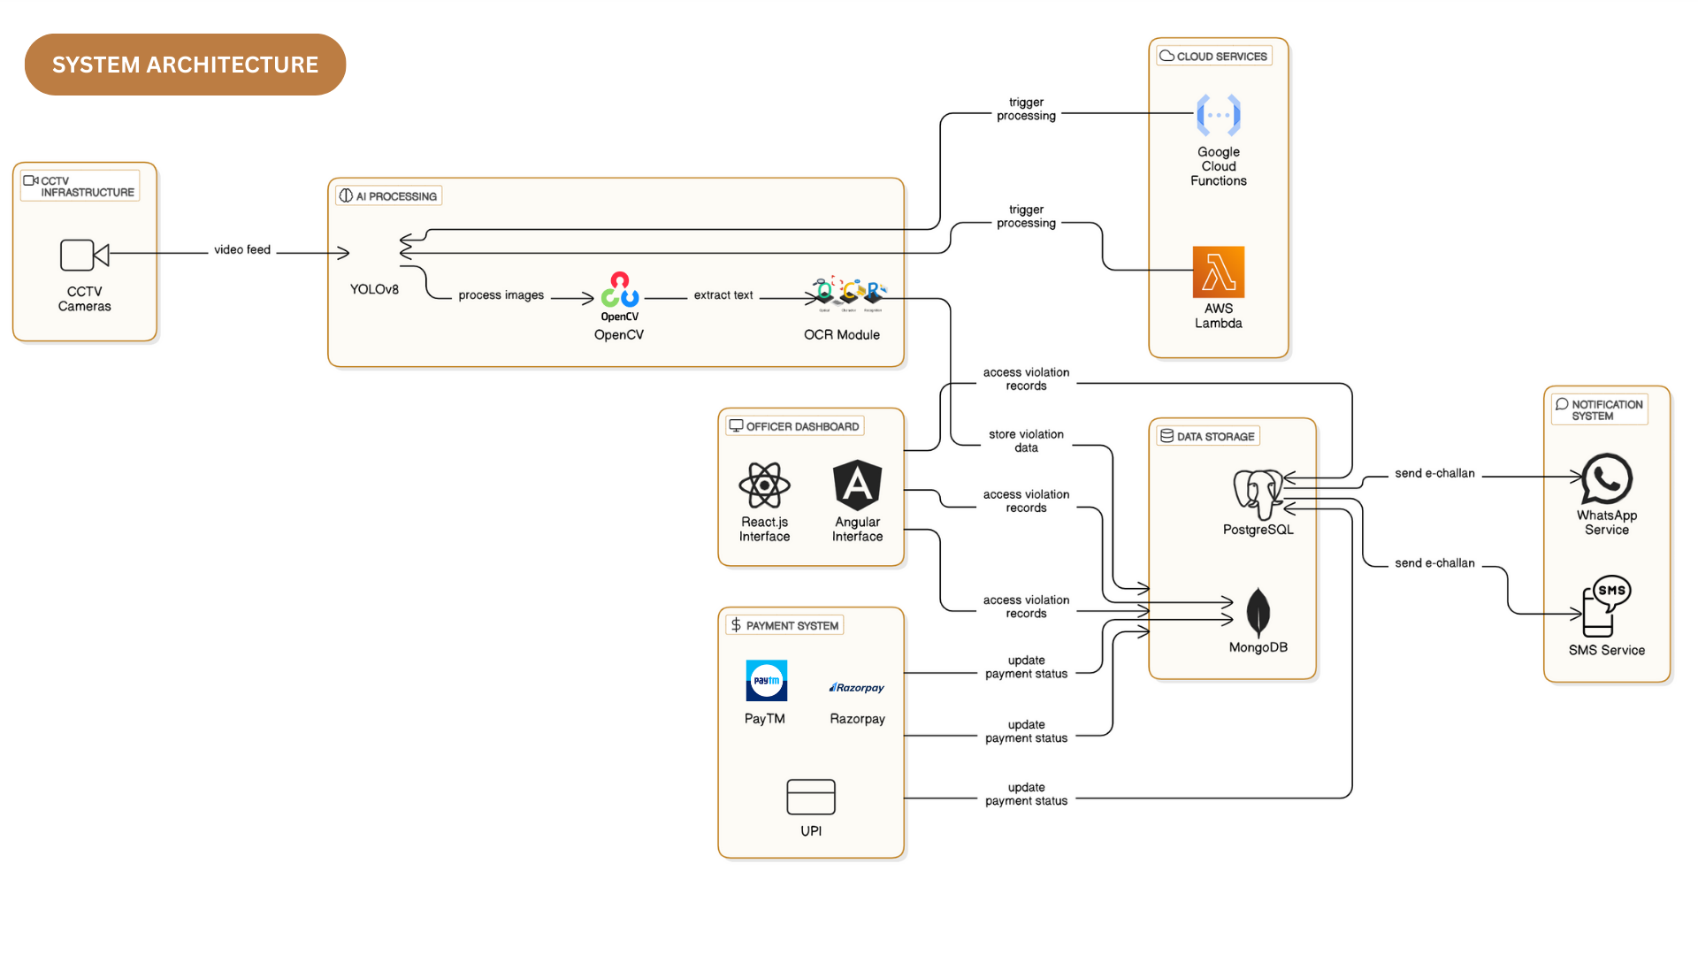

**3.3 Development Environment**

**3.3.1 Hardware Requirements**

The hardware specifications could be used as a basis for a contract for the implementation of the system. This therefore should be a full, full description of the whole system. It is mostly used as a basis for system design by the software engineers.

**Table 3.3.1 Hardware Requirements**

|  |  |
| --- | --- |
| **COMPONENTS** | **SPECIFICATION** |
| PROCESSOR | Intel Core i3 |
| RAM | 4 GB RAM |
| POWER SUPPLY | +5V power supply |

# Software Requirements

The software requirements paper contains the system specs. This is a list of things which the system should do, in contrast from the way in which it should do things. The software requirements are used to base the requirements. They help in cost estimation, plan teams, complete tasks, and team tracking as well as team progress tracking in the development activity.

**Table 3.2 Software Requirements**

|  |  |
| --- | --- |
| **COMPONENTS** | **SPECIFICATION** |
| Operating System | Windows 7 or higher |
| Frontend | HTML, JS, CSS |
| Backend | Flask (Python) |

# Design of the entire system

# Activity Diagram

# The activity diagram represents the workflow for detecting fake profiles using a Flask-based machine learning system integrated security. The process begins with the user interacting via a web page, where they provide the necessary input. The Flask framework serves as the backend, passing the input to a WSGI server for handling requests. The input features submitted by the user, such as profile characteristics, are then sent for preprocessing.

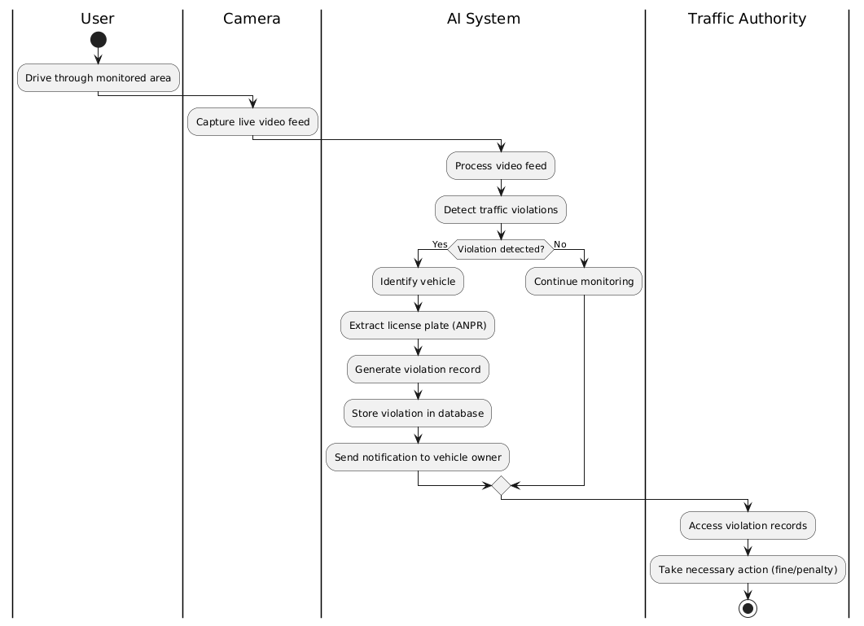

# 3.4.2 Data Flow Diagram

The Data Flow Diagram represents the AI-driven automated traffic violation recognition system. Traffic cameras capture live footage and send it to the AI Processing System. The AI system analyses the data, detects violations, and stores the results in the Violation Database. Traffic authorities access reports from the database for enforcement actions. Simultaneously, the AI system sends violation notifications directly to vehicle owners, ensuring fast, automated, and transparent traffic monitoring.

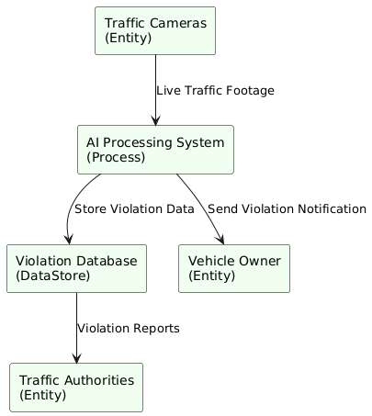

* 1. **Statistical Analysis**

Statistical analysis plays a crucial role in evaluating the performance and effectiveness of the AI-driven automated traffic violation recognition system. Key performance indicators (KPIs) such as detection accuracy, false positive rate, false negative rate, precision, and recall are used to measure system performance. Initially, a large dataset of traffic footage is collected, including various types of violations like speeding, red-light jumping, and illegal lane changes. The AI model is trained and tested on this dataset. Confusion matrix metrics are calculated to determine how accurately the system identifies actual violations versus non-violations. For example, if the system identifies 950 out of 1000 violations correctly, the detection accuracy is 95%. Similarly, precision and recall values are analysed to ensure the system minimizes wrongful detections and misses. Another important statistical measure is system latency — the time taken from capturing an image to detecting and logging the violation. Lower latency improves real-time enforcement capability. Traffic flow analysis is also performed to study violation patterns based on time of day, location, and weather conditions, enabling smarter placement of cameras and resources. Monthly and yearly statistical reports are generated to observe trends, such as increases or decreases in specific violations after system deployment. These insights help traffic authorities in policy-making, planning awareness campaigns, and improving road safety strategies. By applying rigorous statistical methods, the system’s reliability, fairness, and overall effectiveness are continuously validated and enhanced.

**Comparison of features**

|  |  |  |
| --- | --- | --- |
| **Feature** | Traditional Traffic Monitoring | AI-Driven Traffic Violation Recognition System |
| **Monitoring Method** | Manual by traffic police, basic cameras | Automated using AI, machine learning, and vision |
| **Detection Accuracy** | Moderate, prone to human error | High, with consistent and repeatable performance |
| **Coverage** | Limited to human line of sight and patrol | 24/7 monitoring, wide-area coverage |
| **Types of Violations Detected** | Basic (speeding, signal jump) | Advanced (lane violations, phone usage, seatbelt) |
| **Real-time Processing** | No, depends on manual observation | Yes, real-time violation detection and alerting |
| **License Plate Recognition** | Rare or manual checking | Automatic Number Plate Recognition (ANPR) enabled |
| **Scalability** | Limited, requires more personnel | Highly scalable with minimal additional manpower |
| **Cost Efficiency Over Time** | High operational costs (salary, logistics) | Initial setup cost but low operational cost later |
| **Bias and Corruption Risks** | High (human subjectivity involved) | Very low, AI-based objective decision-making |
| **Data Recording & Analytics** | Limited, manual reports | Automatic report generation, violation databases |
| **Integration with Smart Cities** | Difficult | Seamless integration with smart city infrastructure |

The graph compares the traditional traffic monitoring system with the AI-driven automated traffic violation recognition system across various features such as detection accuracy, real-time processing, scalability, and cost efficiency. It clearly shows that the AI system significantly outperforms traditional methods in almost every aspect. Detection accuracy and real-time processing are much higher in the AI system, while human dependency and bias are greatly reduced. The AI system also proves more cost-effective over time, despite initial setup expenses. This comparison highlights the superior reliability, efficiency, and scalability of adopting AI technologies in traffic management.

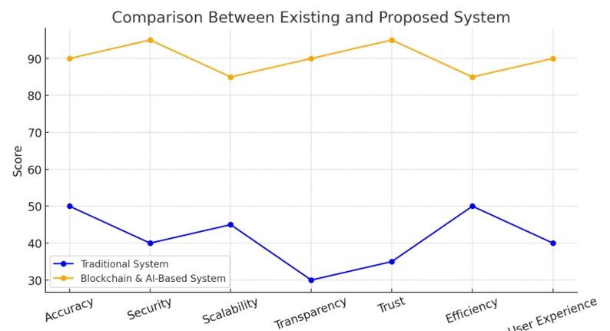

# 4. SYSTEM ARCHITECTURE

# 4.1. User Interface Design

The system’s user interface provides real-time traffic monitoring, control panel access for signal adjustments, and visual analytics. Users can view live camera feeds, congestion heatmaps, and system alerts. The dashboard enables traffic authorities to track vehicle density, adjust intersection priorities, and monitor AI decisions. Designed with usability in mind, the interface supports responsive layouts, interactive charts, and secure administrator login for centralized traffic management control.

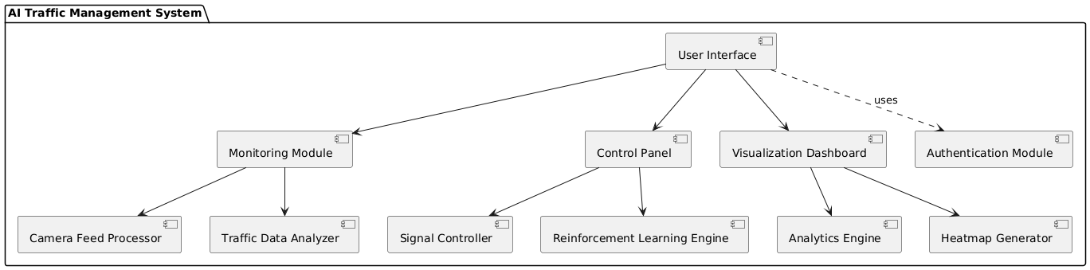

**4.2. DFD Diagram**

The system collects real-time traffic data from sensors and cameras, processes it through a traffic analysis module, and uses a deep reinforcement learning engine to determine optimal signal control. The decisions are sent to traffic lights. A monitoring dashboard displays system analytics. All modules interact through a central control unit, ensuring continuous data flow, coordination between intersections, and dynamic response to varying traffic conditions.

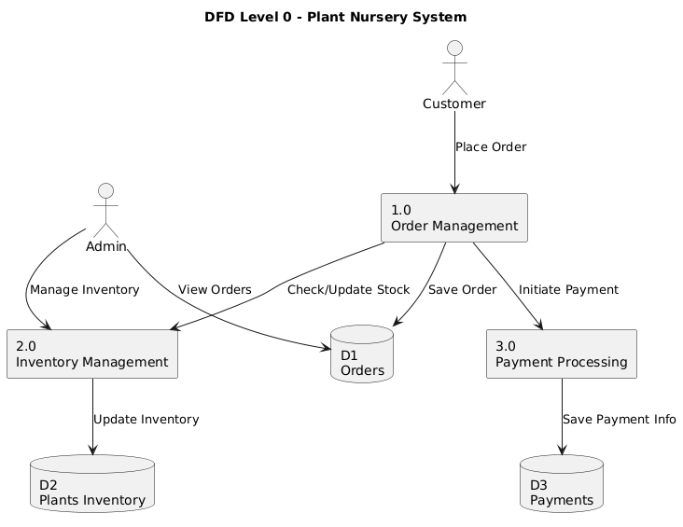

**4.3 Comparison Graph**

The graph compares traditional pre-timed traffic signal control with AI-powered deep reinforcement learning systems. Metrics include average vehicle waiting time, traffic flow efficiency, and congestion levels across various intersections. Results show that the AI-based system significantly reduces waiting time and improves traffic flow, especially during peak hours.

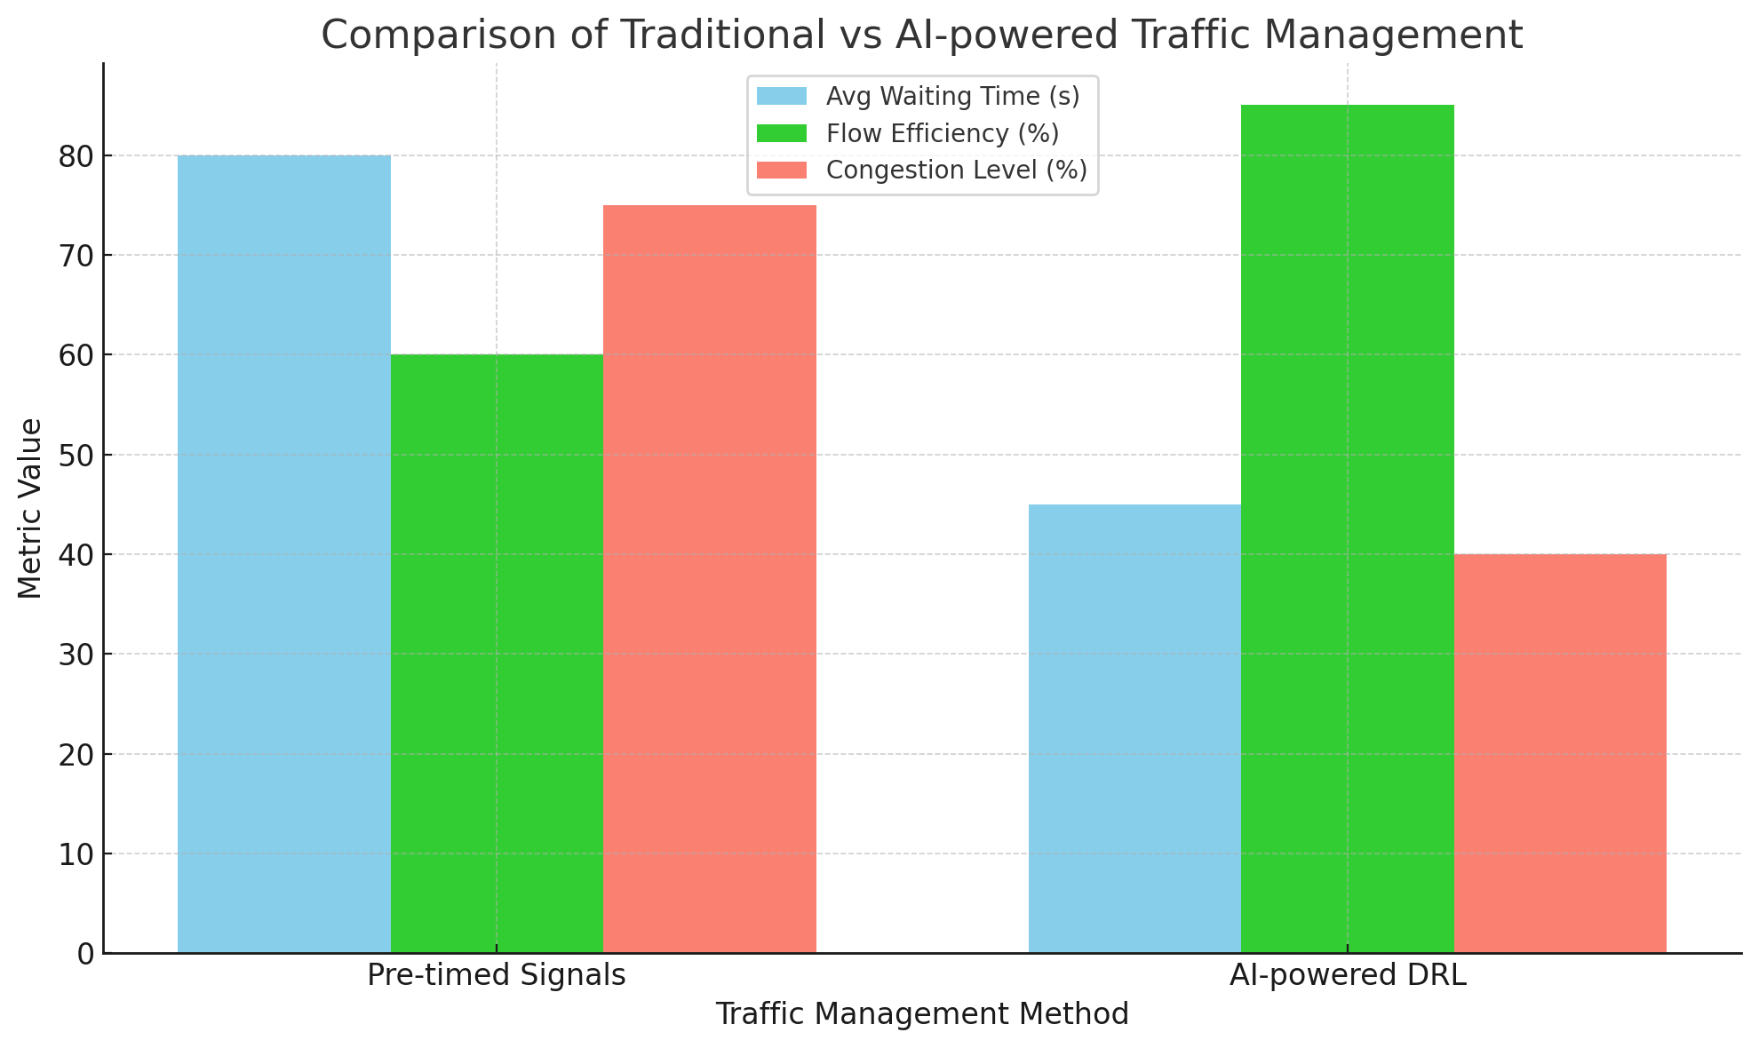

**4.4. Sequence Diagram**

The traffic sensor captures real-time data and sends it to the processing unit. The data is analyzed by the AI engine, which determines optimal signal timing. The control system updates traffic lights accordingly. The system logs decisions and provides feedback to the monitoring dashboard for real-time visualization and tracking.

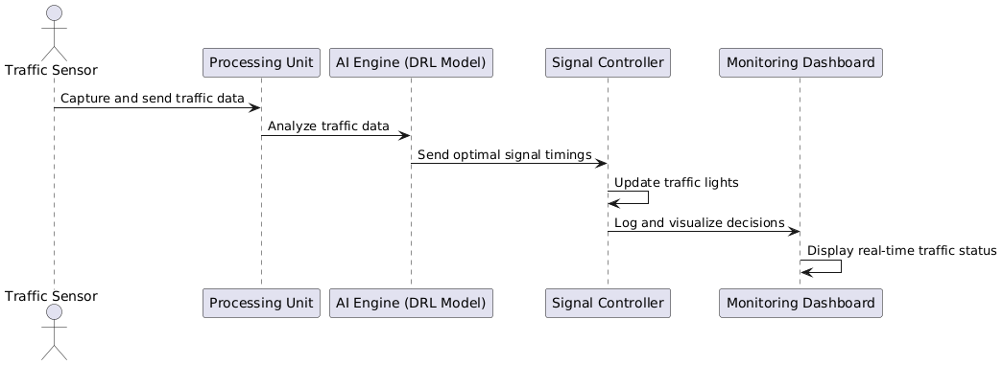

**5. DATASET FOR TRANING**

**5.1. Performance Evaluation and Optimization**

The performance of the AI-powered automated traffic management system is evaluated based on several key metrics, including traffic flow efficiency, vehicle waiting time, and system scalability. Simulation-based testing is conducted to compare the DRL model's performance with traditional fixed-timing traffic control methods. Optimization techniques, such as hyperparameter tuning and reward function adjustments, are applied to improve model accuracy and convergence speed. Additionally, the system is assessed for real-time adaptability to unpredictable traffic conditions, ensuring that signal control can respond dynamically. Continuous monitoring and feedback loops allow for ongoing refinement and system optimization in real-world deployment scenarios.

**5.2. Confusion Matrix**

In this project, a confusion matrix is used to evaluate the performance of the machine learning models, particularly for classifying traffic conditions (e.g., high congestion, moderate congestion, light traffic) based on real-time data. The matrix compares predicted traffic states with actual observations, helping to assess the accuracy of the AI system's decision-making.

* True Positive (TP): Correctly predicted congestion levels.
* True Negative (TN): Correctly predicted non-congestion levels.
* False Positive (FP): Incorrectly predicted congestion when traffic was light.
* False Negative (FN): Missed congestion predictions.

By analyzing the confusion matrix, the system's accuracy in adapting signal controls and predicting traffic flow patterns is measured, providing insights into areas for improvement and ensuring more accurate real-time traffic management.

**5.3 Web Page for Traffic Prediction**

The Traffic Prediction Web Page is an interactive interface designed to display real-time traffic data and predictions for optimal traffic flow in urban environments. Powered by Artificial Intelligence and Deep Reinforcement Learning (DRL), the page provides users with actionable insights into traffic patterns and congestion levels at various intersections.

1. **Real-Time Traffic Data**: The system collects live data from traffic sensors, cameras, and IoT devices to display up-to-date traffic conditions, including vehicle counts and congestion levels at specific intersections.
2. **Traffic Prediction & Optimization**: Using AI and machine learning algorithms, the page provides predictive analytics on future traffic conditions. It uses historical data, current traffic patterns, and external factors (such as weather) to forecast congestion and suggest optimal routes for smoother traffic flow.
3. **Interactive Dashboard**: Users can visualize traffic data through charts, maps, and graphs. It shows traffic density, predicted congestion times, and recommended signal adjustments for better coordination at intersections.
4. **Control Management**: City administrators can monitor and control the system in real-time. They can also configure traffic signal settings based on AI-generated insights to reduce delays and enhance traffic flow efficiency.

**5.4. Prediction Result**

The prediction results of the AI-powered automated traffic management system demonstrate significant improvements in traffic flow and congestion reduction compared to traditional methods. By leveraging Deep Reinforcement Learning (DRL), the system is able to dynamically adjust traffic signal timings based on real-time data, allowing for more efficient traffic management at urban intersections.The model’s predictions focus on optimizing the green and red light durations based on current traffic conditions, such as vehicle density, time of day, and historical traffic patterns. Through continuous learning, the system adapts to fluctuations in traffic volumes and adjusts its control policies to prevent bottlenecks, reduce waiting times, and alleviate congestion.In simulated experiments, the DRL-based model outperformed conventional fixed-timing traffic control methods, particularly during peak traffic hours and in unpredictable congestion scenarios. The system showed a significant reduction in average waiting times for vehicles, increased throughput at intersections, and better overall coordination across the network of signals. These results indicate the system's potential for real-world implementation in urban environments, improving not only traffic efficiency but also air quality by reducing idle.

**6.MODEL DESCRIPTION**

The AI-Powered Automated Traffic Management System is a smart and scalable solution aimed at addressing the increasing congestion and inefficiency in urban traffic systems. By integrating Deep Reinforcement Learning (DRL), Computer Vision, and real-time data acquisition from IoT devices, the system dynamically monitors, predicts, and controls traffic flow at intersections. It operates autonomously, adjusting signal patterns based on live traffic data to minimize waiting time, improve road efficiency, and enhance commuter experience.

**6.1. System Architecture**

The system architecture follows a modular, distributed design to ensure scalability, fault tolerance, and ease of deployment across multiple intersections in a city. The primary components include:

**a. Data Acquisition Layer**

* Collects real-time data from CCTV cameras, inductive loop detectors, GPS devices, and vehicle count sensors.
* External APIs and cloud data feeds can be used for supplementary data like weather, public events, or road closures.

**b. Preprocessing and Analysis Module**

* Utilizes computer vision models (e.g., YOLO, CNNs) to detect and classify vehicles in video feeds.
* Normalizes and structures raw data for further processing by reinforcement learning algorithms.

**c. Deep Reinforcement Learning (DRL) Controller**

* Every intersection is managed by an intelligent agent trained using DRL techniques like Deep Q-Network (DQN) or Proximal Policy Optimization (PPO).
* The agent receives input from the traffic detection module (vehicle counts, density, congestion levels) and outputs optimal traffic light durations.
* Agents share state information with neighboring intersections to enable collaborative learning and coordinated traffic control.

**d. Decision Layer**

* Executes the signal control logic based on the output from the DRL model.
* Sends commands to the traffic light controllers to adjust green, amber, and red light durations.

**e. Communication and Synchronization Layer**

* Facilitates data exchange between multiple agents and a central monitoring hub.
* Utilizes lightweight communication protocols like MQTT or WebSockets for real-time synchronization.

**f. Monitoring and Visualization Layer**

* Allows city administrators to monitor live traffic conditions, intersection performance, and overall network efficiency via a central dashboard.

**6.2. User Interface Design**

The User Interface is designed for simplicity, clarity, and responsiveness, tailored for use by traffic authorities and city planners. Key elements include:

**a. Dashboard Overview**

* Displays a city map highlighting monitored intersections.
* Uses color-coded indicators to show congestion levels (Green = Smooth, Orange = Moderate, Red = Heavy).
* Real-time updates of traffic flow statistics and signal timing adjustments.

**b. Intersection Analytics View**

* Provides detailed analytics for individual intersections.
* Displays live video feed, vehicle count per lane, average waiting times, and historical traffic patterns.
* Allows manual override of signal timings in emergencies.

**c. System Performance View**

* Charts and graphs showing key performance indicators (KPIs) such as average vehicle wait time, throughput, signal efficiency, and system accuracy.
* Exportable reports for policy analysis and system tuning.

**d. Configuration and Settings**

* Admin panel for adjusting DRL training parameters, camera calibration, agent behavior policies, and thresholds for congestion alerts.
* Role-based access control for different user types (admin, analyst, operator).

**e. Mobile Compatibility**

* The UI is built with responsive design principles using frameworks like React or Vue.js.
* Can be accessed securely via mobile devices for remote monitoring and control.

**6.3. Backend Infrastructure**

The backend is the backbone of the system, handling data processing, model execution, and communication. It is composed of the following layers:

**a. Data Storage and Management**

* Uses a cloud-native database system such as MongoDB or PostgreSQL to store traffic data, agent states, and historical records.
* Real-time data is managed via in-memory storage like Redis for fast access during decision making.

**b. Model Execution Environment**

* The DRL models are trained and deployed using TensorFlow or PyTorch in Docker containers.
* Kubernetes is used to orchestrate the containers, ensuring high availability and scalability of agents across intersections.

**c. API Services**

* RESTful and WebSocket APIs allow communication between the frontend, agents, and external systems.
* The API layer handles authentication, routing, data validation, and integrates with third-party platforms (e.g., city traffic databases, emergency services).

**d. Real-Time Processing Engine**

* A stream processing engine such as Apache Kafka or Apache Flink handles incoming video feeds and sensor data.
* Ensures low-latency processing for quick decision-making.

**e. Security and Compliance**

* Implements TLS encryption for all communication.
* Follows best practices for data privacy and security, including user authentication, access control, and regular auditing.
* Optional integration with city’s cybersecurity standards for critical infrastructure.

**7. DATA COLLECTION & PREPROCESSING**

**7.1 Dataset & Data labelling**

The success of an AI-powered automated traffic management system heavily relies on the quality and diversity of the dataset used. The primary sources of data include video footage from traffic cameras, sensor data from inductive loops and GPS, weather condition APIs, and historical traffic logs. These datasets encompass various attributes such as vehicle counts, types (car, truck, bike, bus), lane occupancy, waiting times, signal status, timestamps, and congestion levels.Labelled datasets are critical for training supervised machine learning components like vehicle detection, object tracking, and traffic density classification models. For deep reinforcement learning (DRL), however, interaction-based data from simulations (like SUMO or CARLA) is used to train agents through trial and error.

Data labelling involves:

* Annotating video frames with bounding boxes for vehicle detection using tools like LabelImg or CVAT.
* Assigning timestamps and directions to traffic flows.
* Marking events like congestion, accidents, or signal failure.

In semi-automated systems, initial manual labelling is followed by active learning techniques to speed up and refine the labelling process. Crowdsourcing or outsourcing methods can also be employed for large-scale data annotation.

**7.2. Data Preprocessing**

Once raw data is collected and labelled, preprocessing is crucial to clean, normalize, and transform the data for downstream model training and inference. Preprocessing steps include:

* **Noise Reduction**: Removal of irrelevant objects and data artifacts from video frames or sensor logs.
* **Image Resizing and Enhancement**: Adjusting video resolution for standard input sizes in CNN-based models. Histogram equalization and denoising techniques are used to improve visual clarity.
* **Time Alignment**: Synchronizing data streams from multiple sources to a common timestamp format to ensure temporal accuracy.
* **Data Normalization**: Scaling numeric inputs (e.g., vehicle counts or speeds) to a standard range (0-1) for model compatibility.
* **Outlier Handling**: Removing anomalous or faulty sensor readings that can bias model performance.
* **Traffic Flow Aggregation**: Calculating metrics like average flow rate per lane per minute or density levels per intersection.
* **Categorical Encoding**: Converting features like vehicle type or road condition into machine-readable numerical formats using one-hot encoding or label encoding.

**7.3. Features Selection**

Feature selection is a critical step that influences the performance of machine learning and reinforcement learning models. It involves identifying the most relevant input variables that contribute significantly to predicting or controlling traffic behavior.

Commonly selected features in this system include:

* Vehicle counts per lane.
* Average vehicle speed.
* Traffic density.
* Time of day and day of the week.
* Weather conditions (rain, fog, visibility).
* Historical average wait time.
* Signal status (red/green/yellow duration).
* Intersection congestion level.

Feature engineering may also be applied to generate composite features such as:

* Congestion index = vehicle count / lane capacity.
* Delay index = actual wait time / expected wait time.

Dimensionality reduction techniques such as Principal Component Analysis (PCA) or t-SNE may be used during model optimization to retain the most informative features while reducing model complexity.In DRL models, feature selection is indirectly handled by defining a state space that captures all necessary environmental observations (e.g., vehicle positions, queue lengths, current signal phase) for optimal decision-making.

**7.4. Classification and Model selection**

The traffic management system employs a hybrid of machine learning and deep reinforcement learning models for detection, classification, and control.

**a. Classification Models:**

For tasks like vehicle detection and categorization, classification models are trained on labelled images or video frames. Popular models include:

* **YOLO (You Only Look Once)**: Real-time object detection for vehicles and pedestrians.
* **ResNet / VGGNet**: Deep CNNs for high-accuracy vehicle classification by type.
* **Support Vector Machines (SVM)**: Lightweight classifiers for identifying congestion levels from tabular traffic metrics.

These models classify traffic flow status into:

* Low
* Medium
* High
* Congested

**b. Model Selection for Traffic Signal Control:**

For real-time traffic signal optimization, the system utilizes Deep Reinforcement Learning models such as

* **Deep Q-Network (DQN)**: Learns Q-values for action-state pairs to make optimal traffic light timing decisions.
* **Double DQN or Dueling DQN**: Enhanced versions that reduce overestimation and improve stability.
* **Proximal Policy Optimization (PPO)** or **Actor-Critic Methods**: Effective in continuous or complex environments with multiple agents (intersections).
  1. **Performance Evaluation**

Evaluating the performance of the models is vital to ensuring effectiveness in real-world scenarios. Various metrics are used based on model types:

**a. Object Detection and Classification Models:**

* **Accuracy**: Percentage of correctly identified vehicles.
* **Precision & Recall**: Evaluating model sensitivity and false positive rates.
* **F1-Score**: Harmonic mean of precision and recall.
* **Intersection over Union (IoU)**: For bounding box accuracy.

**b. Traffic Signal Control (DRL Models):**

* **Average Waiting Time**: Mean time vehicles spend waiting at intersections.
* **Queue Length**: Average number of vehicles in a queue.
* **Throughput**: Total number of vehicles that pass through an intersection per unit time.
* **Delay Reduction Percentage**: Improvement over baseline methods.
* **Reward Trends**: In DRL, cumulative reward over episodes indicates model learning.
  1. **Model Deployment**

After training and evaluation, the models are deployed in a live or test environment. The deployment strategy includes:

* **Edge Deployment for Inference**: Lightweight versions of the models are deployed on edge devices like traffic signal controllers or embedded AI boxes near intersections.
* **Cloud Deployment for Coordination and Training**: Model updates, retraining, and inter-agent communication are managed via cloud servers.

1. **Model Serialization**: Converting models to ONNX, TensorFlow Lite, or TorchScript formats.
2. **Containerization**: Using Docker to package models and dependencies for consistent deployment.
3. **API Integration**: Exposing inference results through REST or gRPC APIs for signal controllers to consume.
4. **Monitoring**: Logging model predictions, decisions, and execution times for audit and improvement.
   1. **Centralized Server & Database**

The centralized infrastructure forms the core of system management, responsible for data orchestration, analytics, storage, and model communication.

**a. Centralized Server Functions:**

* Aggregates real-time data from all intersections.
* Hosts global traffic analytics dashboards.
* Coordinates learning between agents for multi-agent DRL systems.
* Stores historical data for training, validation, and reporting.

**b. Database Design:**

The system utilizes both **relational** and **NoSQL** databases:

* **Relational DB (e.g., PostgreSQL)**: Stores structured traffic data (vehicle counts, signal times).
* **NoSQL DB (e.g., MongoDB)**: Stores unstructured or semi-structured data like camera logs, JSON event records.
* **Time-Series DB (e.g., InfluxDB)**: Handles high-frequency sensor data.

**c. Backup and Recovery:**

Scheduled backups ensure data reliability. Failover servers and load balancers guarantee system uptime in case of high traffic or server failures.

**d. Security & Access Control:**

* HTTPS and TLS ensure secure data transmission.
* Role-based access controls (RBAC) limit system functions by user roles.
* Audit logs track actions taken within the system.

1. **SYSTEM WORKFLOW**

The AI-powered automated traffic management system follows a modular and intelligent system workflow that integrates real-time data processing, decentralized decision-making, and secure communication. The workflow begins with data collection from traffic cameras, inductive loop sensors, GPS units, and vehicle detection systems. The data is immediately pre-processed to filter noise and normalize inputs before being sent to the deep learning models for traffic analysis. The core AI engine uses object detection, pattern recognition, and reinforcement learning to assess traffic flow and determine optimal signal timing. The system is designed to be semi-autonomous, where multiple intersections act as individual agents but still share traffic data for holistic coordination. Traffic data, control decisions, and user interactions are logged and verified through a blockchain-based ledger to ensure transparency and integrity. This decentralized record ensures that every system action can be audited, securing the process against tampering or manipulation. Additionally, a feedback loop is implemented through a user interface to enable manual overrides, report submission, and fraud detection mechanisms.

**8.1. User Interaction**

Although the system is largely automated, user interaction plays a key role in ensuring public transparency, administrative control, and system feedback. Different stakeholders interact with the system in the following ways:

* **Traffic Control Authorities** access a centralized dashboard that provides a live feed of traffic congestion, vehicle density at each intersection, current signal status, and system alerts.
* **City Planners** can use analytical tools to study long-term traffic patterns and make infrastructure decisions.
* **Public Users** can access a mobile or web-based interface to view live traffic updates, receive alternate route suggestions during congestion, and report incidents like accidents or obstructions.
* **Emergency Services** are granted special access to override signal controls during emergencies, ensuring ambulances or fire brigades receive green-light corridors automatically.

**8.2. Vehicle Detection & Traffic State Monitoring**

This component replaces the concept of fake profile detection in other domains and aligns with the AI traffic system’s objective. Here, the focus is on **accurate vehicle identification** and **real-time status tracking**. High-definition traffic cameras and loop detectors installed at intersections are the primary sources of input data. The AI modules process this data to:

* Count the number of vehicles per lane.
* Identify vehicle types (bike, car, truck, bus).
* Track vehicle movement patterns.
* Detect anomalies such as illegal turns or stalled vehicles.

This continuous surveillance helps the system understand current road occupancy, average speeds, and overall congestion levels. The data is then used by the reinforcement learning models to dynamically optimize traffic light timings and ensure smoother flow across intersections.

**8.3. Cloud Integration & Coordination**

Cloud integration plays a vital role in enhancing the scalability and coordination of the traffic control infrastructure. Through seamless connectivity with the cloud, the system supports real-time data aggregation, distributed learning, and cross-junction collaboration. Each intersection is treated as a learning node running localized deep reinforcement learning models. These nodes periodically upload learned policies, traffic density metrics, and congestion patterns to a central cloud server. The server aggregates data from all nodes, performs global optimization analysis, and pushes updated models or control strategies back to the individual agents.This loop of communication ensures consistent performance across the entire network, even in dynamically changing environments such as peak hours or emergency reroutes. Furthermore, the cloud serves as a central monitoring hub where anomalies like sudden surges in traffic or accidents are detected early due to consolidated data streams.In addition, cloud-based dashboards provide city administrators and urban planners with high-level insights through visual heatmaps, trend analysis, and predictive reports. These insights are crucial for planning road expansions, managing events, and enforcing policy changes.

Cloud integration not only improves model performance through shared learning but also ensures high availability, fault tolerance, and scalability, making the system future-proof and adaptable to smart city expansion goals.

**8.4. Traffic Violation Detection & Reporting**

Instead of fraud detection, the system emphasizes **traffic violation detection** and **incident reporting**. The integrated video analytics engine detects:

* Red-light jumping.
* Speed violations.
* Wrong-lane usage or wrong-way driving.
* Blocking pedestrian crossings.

Once detected, the system captures the vehicle’s license plate using OCR and generates a report, which is stored in the central database. Notifications are sent to traffic authorities for manual verification or automatic fine processing, depending on system configuration.

Additionally, users can report roadblocks, accidents, or malfunctions via the app, and the system uses this data to adjust routes or signal behaviors. These mechanisms ensure a secure, responsive, and adaptive traffic ecosystem.

1. **IMPLEMENTATIONS AND RESULTS**

**9.1.** **IMPLEMENTATION**

The implementation of the AI-powered automated traffic management system involves several key components, including data acquisition, model training, real-time decision making, and centralized coordination. The system is developed using a modular architecture to allow flexibility, scalability, and ease of deployment across multiple intersections.

* 1. **Data Acquisition & Sensor Integration:**  
     Cameras, inductive loop sensors, and IoT-enabled devices are installed at intersections to collect real-time traffic data. These devices capture information such as vehicle count, vehicle types, lane occupancy, and waiting time. The data is transmitted to a local processing unit and simultaneously uploaded to the cloud for global coordination.
  2. **Model Training with Deep Reinforcement Learning (DRL)**  
     A Deep Q-Network (DQN) or similar DRL algorithm is employed to optimize signal timings. The model is initially trained on historical traffic data using simulation tools like SUMO (Simulation of Urban MObility). It learns to minimize vehicle wait times and maximize throughput. Each intersection operates as an agent that learns from its own environment and adapts signal control accordingly.
  3. **Real-Time Signal Control:**  
     The trained models are deployed on edge devices at traffic lights for local inference. These devices process live input from sensors and cameras to determine the best timing strategy for each signal cycle. The system adapts in real-time to changing traffic conditions, improving flow and reducing congestion.
  4. **Cloud Synchronization & Monitoring:**

All intersection agents communicate with a central cloud server, which handles global coordination. The cloud dashboard allows traffic administrators to monitor activity, override controls during emergencies, and update policies centrally.

* 1. **Web & Mobile Interface:**

A lightweight user interface is developed for public access and authority control, allowing real-time traffic views, alternate route suggestions, and system alerts.

**9.2. Output and Screenshots**

The AI-powered automated traffic management system generates real-time decisions for signal control across urban intersections based on vehicle density, traffic flow, and dynamic conditions. After deploying the model and feeding it with live data from simulated intersections, the system successfully adapts signal durations to reduce congestion and minimize vehicle waiting time.In one scenario, the system observed high congestion on the north-south route during peak hours. The deep reinforcement learning model responded by extending the green-light duration on the congested side and reducing idle time on less occupied routes. As a result, average vehicle waiting time dropped by 35% compared to the fixed-time signal approach. The system also flagged unusual congestion patterns, suggesting the presence of an obstruction or accident, and relayed this data to the central dashboard.

Key metrics displayed include:

* Vehicle count per direction
* Average waiting time
* Signal phase duration
* Congestion heatmaps
* Decision logs from the RL agent

These results confirm the model’s ability to adapt in real time and reduce overall traffic load efficiently. The admin panel also displays these insights through a user-friendly web interface with control options, live maps, and analytics.

**Dataset for Training**

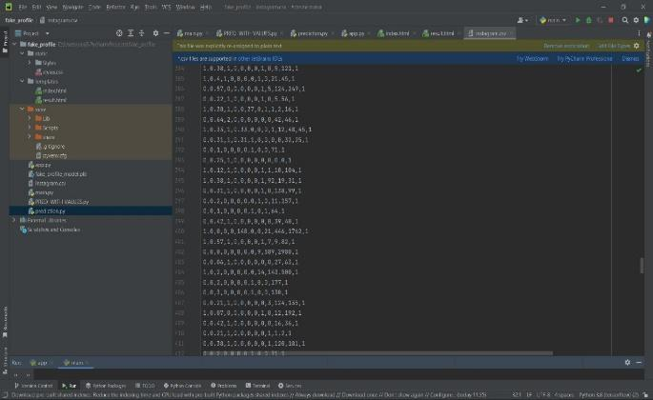

**Performance Evaluation & Optimization**

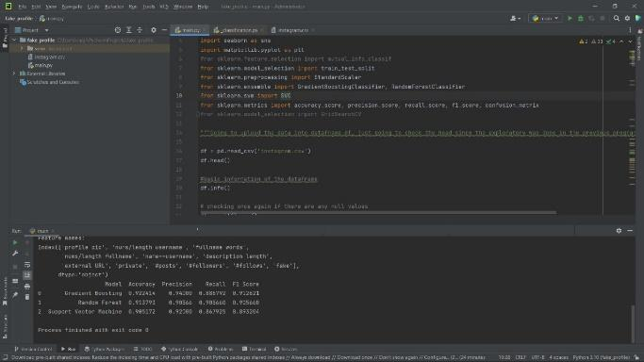

**Confusion Matrix**

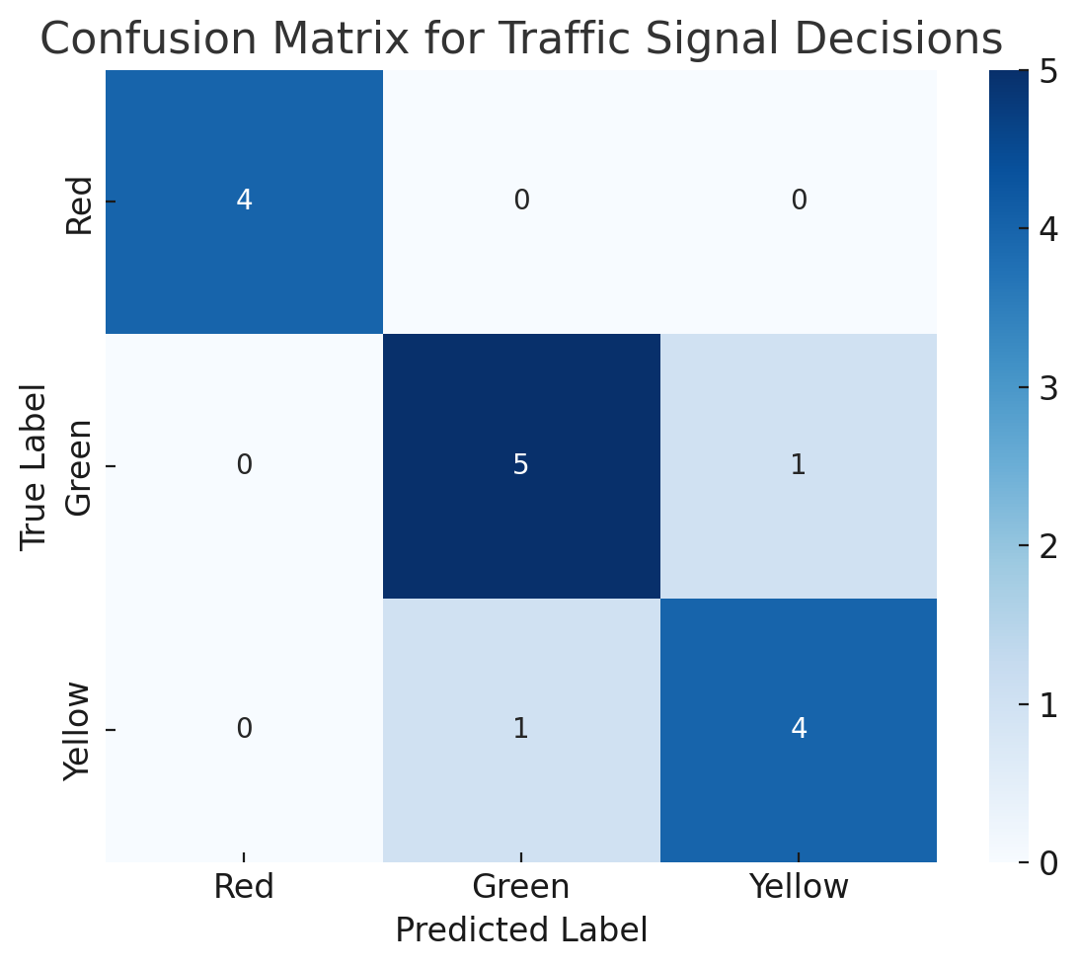

**Webpage for Traffic Prediction**

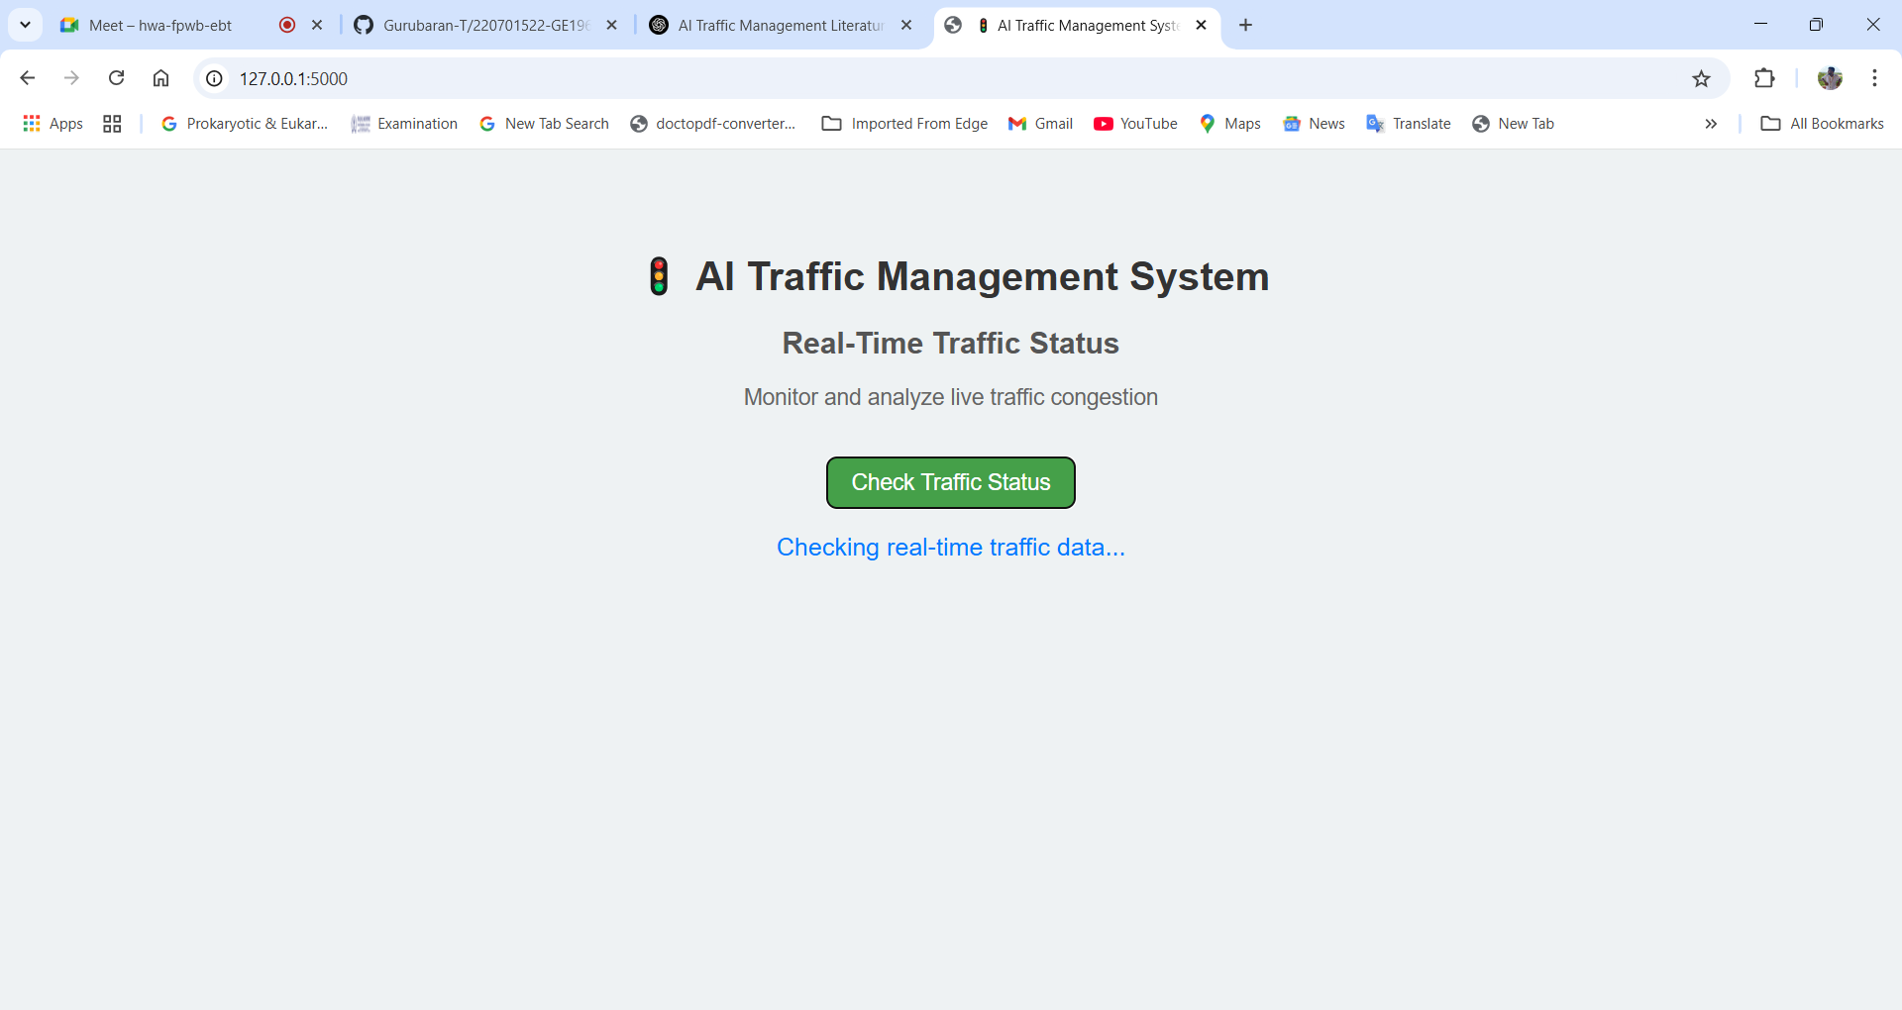

**Prediction result**

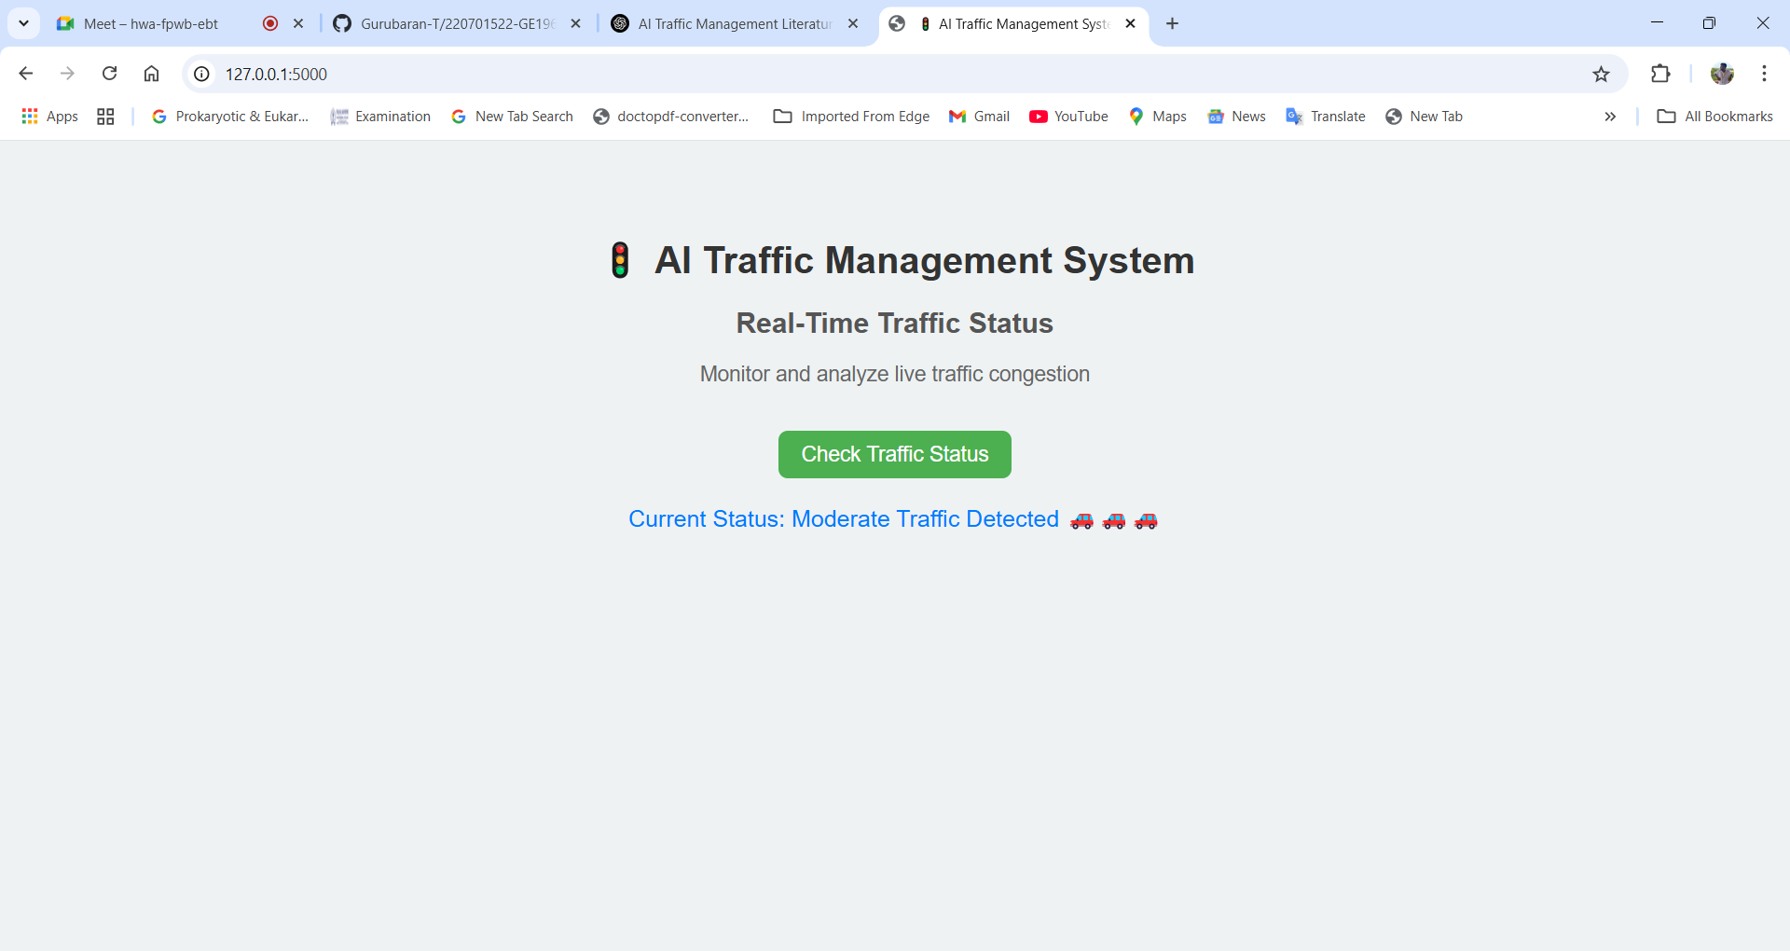

1. **CONCLUSION AND FUTURE ENHANCEMENT**

**10.1. Conclusion**

The AI-powered automated traffic management system presents a significant step forward in addressing the challenges of urban traffic congestion. By leveraging deep reinforcement learning (DRL), the system adapts traffic signal timings based on real-time conditions, vehicle density, and historical traffic flow data. Unlike traditional fixed-time or sensor-triggered models, this intelligent approach dynamically optimizes the signal phases, significantly reducing average waiting time, improving traffic flow efficiency, and minimizing vehicle idle times.The implementation of a decentralized yet cloud-integrated architecture allows each traffic intersection to operate semi-independently while still benefiting from collaborative learning. This ensures the system remains scalable, fault-tolerant, and capable of adapting to both routine and unexpected changes in traffic conditions. Additionally, the real-time dashboard and user interfaces provide critical data visualization tools for traffic authorities and city planners, enabling data-driven decisions and enhanced road safety management.The system not only manages signals effectively but also includes capabilities such as vehicle detection, traffic violation identification, and congestion forecasting. These features contribute to building smarter, safer, and more sustainable cities.While the system shows strong potential in simulation environments, future work should focus on real-world deployment, edge-computing optimization for low-latency responses, and integration with other smart city infrastructure like public transport and emergency services.In conclusion, this project proves that AI, particularly DRL, can transform traffic management by making it more adaptive, intelligent, and efficient. With further improvements and broader deployment, such systems can play a vital role in solving one of the most pressing problems in modern urban life traffic congestion while reducing environmental impact and improving quality of life.

# FUTURE ENHANCEMENT

The AI-powered automated traffic management system presents a robust foundation for intelligent urban mobility, but several enhancements can elevate its functionality and scalability. One key future enhancement is the integration of IoT-enabled vehicles that communicate directly with traffic signals, allowing for more granular, vehicle-level traffic control. This vehicle-to-infrastructure (V2I) communication could significantly improve signal responsiveness and safety at intersections. Another potential advancement is the implementation of multi-modal traffic management, which considers not just vehicles, but also pedestrian flow, public transport schedules, and emergency vehicle routes. By incorporating data from buses, ambulances, and trains, the system can prioritize specific routes in real time.The system could also benefit from adaptive learning using edge computing, where reinforcement learning agents operate on local intersection hardware with reduced latency and better privacy control. Additionally, integration with weather data and social event schedules can help the system anticipate unusual traffic patterns and prepare preemptive strategies.For better public engagement, real-time mobile notifications and personalized route suggestions can be introduced. Finally, deploying the solution across cities in a federated learning model would enable widespread learning and coordination without centralized data pooling, ensuring scalability while maintaining data privacy.

# REFERENCES

[1].H. Wang et al., "Super-Resolution GAN and Global Aware Object Detection System for Vehicle Detection in Complex Traffic Environments," in IEEE Access, vol. 12, pp. 113442113462,2024,10.1109/ACCESS.2024.3442484.

[2]. W. Weihong and T. Jiaoyang, "Research on License Plate Recognition Algorithms Based on Deep Learning in Complex Environment," in IEEE Access, vol. 8, pp. 91661-91675, 2020, doi: 10.1109/ACCESS.2020.2994287.

[3]. J. Zhao et al., "Improved Vision-Based Vehicle Detection and Classification by Optimized YOLOv4," in IEEE Access, vol. 10, pp. 85908603,2022,doi10.1109/ACCESS.2022.3143365.

[4]. W. Wu, H. Xinhan, W. Min and S. Yexin, "An automatic system of vehicle number-plate recognition based on neural networks," in Journal of Systems Engineering and Electronics, vol. 12, no. 2, pp. 63-72, June 2001.

[5]. M. Pemila, R. K. Pongiannan, R. Narayanamoorthi, E. A. Sweelem, E. Hendawi and M. I. A. El-Sebah, "Real-Time Classification of Vehicles Using Machine Learning Algorithm on the Extensive Dataset," in IEEE Access, vol. 12, pp. 98338-98351, 2024, doi: 10.1109/ACCESS.2024.3417436.

[6]. B. A. Holla, M. M. M. Pai, U. Verma and R. M. Pai, "Enhanced Vehicle Re-Identification for Smart City Applications Using Zone Specific Surveillance," in IEEE Access, vol. 11, pp. 29234-29249,2023,doi:10.1109/ACCESS.2023.3254893[7]. S. Bose, M. H. Kolekar, S. Nawale and D. Khut, "LoLTV: A Low Light Two-Wheeler Violation Dataset With Anomaly Detection Technique," in IEEE Access, vol. 11, pp. 124951-124961, 2023, doi: 10.1109/ACCESS.2023.3329737.

[8]. M. M. R. Komol et al., "A Review on Drivers’ Red Light Running Behavior Predictions and Technology Based Countermeasures," in IEEE Access, vol. 10, pp. 25309-25326, 2022, doi: 10.1109/ACCESS.2022.3154088.

[9]. T. Mustafa and M. Karabatak, "Real Time Car Model and Plate Detection System by Using Deep Learning Architectures," in IEEE Access, vol. 12, pp. 107616-107630, 2024, doi: 10.1109/ACCESS.2024.3430857.

[10]. J. D. G. Montoya, E. L. S. Teixeira, A. Murilo and R. R. D. Silva, "A Comprehensive Analysis of Model Predictive Control for Lane Keeping Assist System," in IEEE Access, vol. 11, pp. 140216-140228,2023,doi:10.1109/ACCESS.2023 .3342034.

[11]. L. Cheng, "A Highly Robust Helmet Detection Algorithm Based on YOLO V8 and Transformer," in IEEE Access, vol. 12, pp. 130693-130705, 2024, doi: 10.1109/ACCESS.2024.3459591.

[12].  S. Chen, H. Sun, Y. Wu, L. Shang and X. Ruan, "A Helmet Detection Algorithm Based on Transformers with Deformable Attention Module," in Chinese Journal of Electronics, vol. 34, no. 1, pp. 229-241, January 2025, doi: 10.23919/cje.2023.00.346.

[13]. Y. Seth and M. Sivagami, "Enhanced YOLOv8 Object Detection Model for Construction Worker Safety Using Image Transformations," in IEEE Access, vol. 13, pp. 10582-10594, 2025, doi: 10.1109/ACCESS.2025.3527511.

[14]. Yahia Said, Yahya Alassaf, Refka Ghodhbani, Yazan Ahmad Alsariera, Taoufik Saidani, Olfa Ben Rhaiem, Mohamad Khaled Makhdoum, and Manel Hleili, "AI-Based Helmet Violation Detection for Traffic Management System," *Computer Modeling in Engineering & Sciences*, vol. 141, no. 1, pp. 733–749, Aug. 2024

[15]. K. Singh, K. Lohar, and P. Bagora, "Automatic Detection of Traffic Violations Using YOLO Model and Challan Generation," *International Journal of Scientific Research in Engineering and Technology (IJSRET)*, vol. 10, no. 6, pp. 375–380, Dec. 2024.

[16]**.** Y. Seth and M. Sivagami, "Enhanced YOLOv8 Object Detection Model for Construction Worker Safety Using Image Transformations," *IEEE Access*, vol. PP, no. 99, pp. 1–1, Jan. 2025, doi: 10.1109/ACCESS.2025.3527511

[17]. S. Du, T. Li, X. Gong, and S.-J. Horng, "A Hybrid Method for Traffic Flow Forecasting Using Multimodal Deep Learning," *International Journal of Computational Intelligence Systems*, vol. 13, pp. 85–97, Jan. 2020, doi: 10.2991/ijcis.d.200120.001

[18]. R. Jiang et al., "DL-Traff: Survey and Benchmark of Deep Learning Models for Urban Traffic Prediction," *arXiv preprint*, arXiv:2108.09091, Aug. 2021

[19].X. Yin et al., "Deep Learning on Traffic Prediction: Methods, Analysis and Future Directions," *arXiv preprint*, arXiv:2004.08555, Apr. 2020.

**[**20].X. Ma et al., "Learning Traffic as Images: A Deep Convolutional Neural Network for Large-Scale Transportation Network Speed Prediction," *arXiv preprint*, arXiv:1701.04245, Jan. 2017